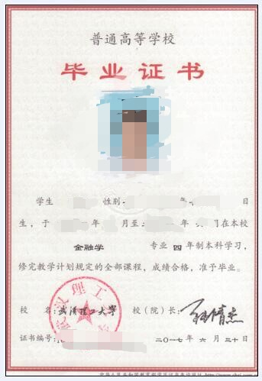

Diploma
Date of Issue: 06/30/2017
Certificate No. XXXXXXXXX
Student XXXXXXXXX, female, born on 02/10/1995, was admitted to the Finance major of this University in September 2013. By June 2017, she has successfully completed all the courses required by the four-year undergraduate program and earned enough credits. Thus, she is allowed to graduate.

President: Zhang Qingjie

Wuhan University of Technology

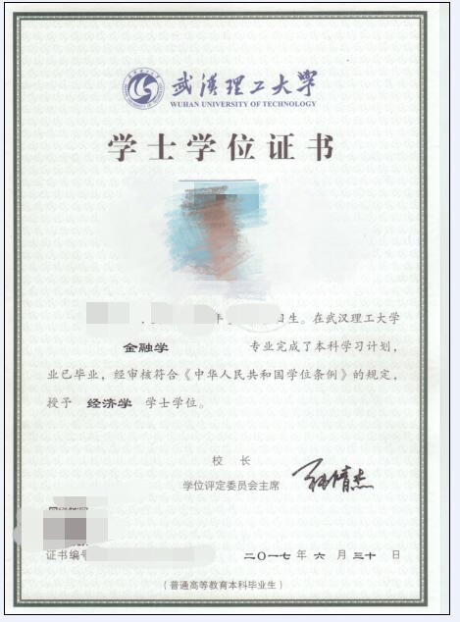

Certificate for Degree of Bachelor
Date of Issue: 06/30/2017
Certificate No. XXXXXXXXX
Student XX, female, born on 02/10/1995, has successfully completed all the courses required by the undergraduate program of the Finance major of Wuhan University of Technology, and has been allowed to graduate. In accordance with the Regulations on Academic Degrees of the People’s Republic of China, she is conferred the Bachelor degree of Economics.

President: Zhang Qingjie

Chairman of Degree Evaluation Committee
Wuhan University of Technology

